Government Information Technology Management
B-BBEE Technical Specification

Version Control
Created by | GITM DIRECTORATE
Created Date | September 2018
Version | 1.0

SIGN OFF
Initials and Surname | Title | Signature | Date
Ms A Barkhuizen | Director: Government Information and Technology Management

Contents
Cover Page 1
1. INTRODUCTION 3
2. BACKGROUND 3
3. PURPOSE 3
4. SCOPE 4
5. SYSTEM REQUIREMENTS 4
6. DATABASE DESIGN OF PLANNING 5
7. DATABASE RELATIONSHIP 10
8. SCREEN DESIGN OF PLANNING 10
9. REPORTS 16

Table of Figures
Table 1 Buyer Information 5
Table 2 Supplier Information 6
Table 3 Company Details Information 7
Table 4 Company Reference Information 7
Table 5 Company Footprint Information 8
Table 6 Products and Services Information 8
Table 7 Tourism Enterprise Information 9
Table 8 Document Upload Information 9

Figure 1 Context Diagram 4
Figure 2 Database Relationship 10
Figure 3 Buyer Form 11
Figure 4 Supplier Form 12
Figure 5 Supplier Form Continuation from Buyer Form 13
Figure 6 Company Details Form 13
Figure 7 Company Footprint Form 14
Figure 8 Commercial References Form 14
Figure 9 Attachment Documents Form 15
Figure 10 Tourism Enterprises Form 15
Figure 11 Continuation of Tourism Enterprises 16
Figure 12 Search for Suppliers Form 16

- INTRODUCTION

The department of Tourism wishes to develop the Portal which will facilitate business connections between large and small enterprises to stimulate development and sustainable economic growth. Furthermore, it will provide procurement tools to make it simple for procurement professionals to connect to valid small black owned enterprises that can successfully deliver against the required procurement targets.

- BACKGROUND

Following the baseline study on the state of transformation in the tourism sector, it was found that one of the many reasons that there is low procurement spend by large enterprises on black owned suppliers is due to the lack of reliable information and the inordinate amount of time required by large enterprises to identify and verify black owned suppliers. The Council recommended that the Sector Transformation directorate should conduct a further study to determine the feasibility of creating a portal for black owned suppliers to meet and engage with large buyers.

Accordingly, during 2014/15 financial year, the Sector Transformation directorate conducted the feasibility study on the development and maintenance of the portal. The feasibility report made the following two recommendations: First, insourcing; which will be beneficial to the Department of Tourism as the infrastructure and skills will be owned by the department. Second, outsourcing, which will be a better option for a short-term investment as the resources used such as skills, infrastructure, operational licence and software belong to the established company in the market.

Following deliberations on the findings of the feasibility study by the management of the Department at Lekgotla in February 2015, it was resolved that given budget constraints, the Government Information and Technology Management (GITM) directorate should be responsible for the development and maintenance of the portal guided by the Terms of Reference developed by the Sector Transformation directorate.

Then, during the investigations it was found that the development and maintenance of the portal carry significant liabilities and risks such that it would be preferable to outsource the work to a service provider who has already build a similar portal and engaged with the industry. Therefore an external Service Provider will be appointed. In the 2016/17 financial year, the department will implement a pilot project with 1000 suppliers in order to evaluate the performance of the project before it is fully implemented.

- PURPOSE

The purpose of this document is to provide the Technical Specification for this application to ensure the clear understanding of what the Technical Team are supposed to build in satisfying the overall business requirements and ensure internal standards and best practices are met. This document does not precisely define the solution to be implement rather it define the concept of the solutions.

- SCOPE

The scope of this project is to develop the website portal using SharePoint and MS SQL Database. The portal will provide procurement tools to make it simple for procurement professionals to connect to valid small black owned enterprises that can successfully deliver against the required procurement targets. The system will allow Users registration, send Alerts , Supplier, provide Tourism Enterprises Supporting Documents, Customer Feedback , Support List for Administrators , advertisement Opportunities or Tenders, allow supplier search and supplier’s information varication.

- SYSTEM REQUIREMENTS

Context Diagram

National Treasury CSD

Department/
Council
Supplier Validation

Reports

BBBEEE Portal

Supplier

Register
Business Verification

Register
Search for supplier

Buyer

Figure 1 Context Diagram
This Portal will allow the buyer to register on the database and be able to search for suppliers.
The suppliers, buyer and Tourism Enterprises will register, their businesses on the database. The supplier’s business information should be verified by the National Treasury CSD, such as business registration, VAT status and Tax Compliance. The system will have the link to the National Treasury CSD for verification. The Department should be able to extract different reports from the portal. The system should cater for the integration with other external systems ( CSD and SANAS).
The system should allow the a user to also register to more than one user type that is a user can register as buyer ,supplier and as Tourism Enterprises

- DATABASE DESIGN OF PLANNING

Buyer Table
Fields Name | Data Type | Values
Register Number | Number | 0000/000000/00
Enterprise Name | Text
Trading Name | Text
Enterprise Type | Drop Down | Private company  Public listed company  Personal Liability Company  Partnership  Business trust  Sole proprietorship  State Owned Companies  Partnership  Close corporation  Public non-listed company  Trust  Co-operative  Incorporation  Public benefit organisation  Limited by guarantee
Are you VAT Registered | Drop Down | Yes  No
VAT Registration Number | Number
Income Tax Number | Number | 0000/000/000
Tax Clearance Number | Number | 0000000000
Username | Text
First name | Text
Last name | Text
Password | Text
Confirm password | Text

Table 1 Buyer Information

Supplier Table
Fields Name | Data Type | Values
Register Number | Number | 0000/000000/00
Enterprise Name | Text
Username | Text
Password | Text
Confirm password | Text
Enterprise Trading Name | Text
Enterprise Type | Drop Down | Private company  Public listed company  Personal Liability Company  Partnership  Business trust  Sole proprietorship  State Owned Companies  Partnership  Close corporation  Public non-listed company  Trust  Co-operative  Incorporation  Public benefit organisation  Limited by guarantee
Are you VAT Registered | Drop Down | Yes  No
VAT Registration Number | Number
Income Tax Number | Number | 0000/000/000
Tax Clearance Number | Number | 0000000000
Trading start date | Date picker
Telephone / switchboard | +27 00 – 000 - 0000
Email address | Text | Must be a valid email address
Website address | Text
Number of employees | Number
Industry sector | Text
Grading Level | Drop down | One star  Two stars  Three stars  Four stars  Five stars
First name | Text
Last name | Text
Holding Company Name Applicable | Drop Down | Yes  No
Holding Company Name | Text
Table 2 Supplier Information

Company Details Table
Fields Name | Data Type | Values
Street Number | Text
Street Name | Text
Suburb | Text
City/Town | Text
Province | Drop Down | Gauteng  KwaZulu-Natal  Western Cape  Eastern Cape  North West  Mpumalanga  Free State  Limpopo  Northern Cape
Postal Code | Number
Same as Physical Address | Check Box
Street Number | Text
Street Name | Text
Suburb | Text
City/Town | Text
Province | Drop Down | Gauteng  KwaZulu-Natal  Western Cape  Eastern Cape  North West  Mpumalanga  Free State  Limpopo  Northern Cape
Postal Code | Number

Table 3 Company Details Information

Company References Table
Fields Name | Data Type | Values
Phone Number | Number | +27 00 – 000 - 0000
Company Name | Text
Contact Person | Text
Email Address | Text | Must be a valid email address

Table 4 Company Reference Information

Company Footprint Table
Fields Name | Data Type | Values
Provincial | Check box | Gauteng  KwaZulu-Natal  Western Cape  Eastern Cape  North West  Mpumalanga  Free State  Limpopo  Northern Cape  Nationally
International | Check box | Africa  Asia  Australia  Europe  North America  South America

Table 5 Company Footprint Information

Products and Services Table
Fields Name | Data Type | Values
List products / services offered by your company | Text
Does your company have at least one year track record providing the goods and services captured? | Drop down | Yes  No
Please provide number of years' experience | Number

Table 6 Products and Services Information

Tourism Enterprise Table
Fields Name | Data Type | Values
Register Number | Number | 0000/000000/00
Enterprise Name | Text
Are you VAT Registered | Drop Down | Yes  No
VAT Registration Number | Number
Income Tax Number | Number | 0000/000/000
Tax Clearance Number | Number | 0000000000
Sub-sector | Drop Down | Accommodation  Travel  Tourist Guide
Grading Level | Drop down | One star  Two stars  Three stars  Four stars  Five stars
Email Address | Text | Must be a valid email address
B-BBEE Expiry Date | Date
Province | Drop Down | Gauteng  KwaZulu-Natal  Western Cape  Eastern Cape  North West  Mpumalanga  Free State  Limpopo  Northern Cape
Annual revenue | Numeric | Currency (R)
Black ownership % | Numeric | Percentage (%)
Black women ownership % | Numeric | Percentage (%)
Black executive management % | Numeric | Percentage (%)
Black women executive management % | Numeric | Percentage (%)
Industry sector | Text
Password | Text
Confirm password | Text
Table 7 Tourism Enterprise Information

Document Upload Table
Fields Name | Data Type | Values
B-BBEE verification certificate / EME Affidavit | Document
Valid SARS Tax Clearance Certificate | Document
Accreditation documents | Document
Company registration document | Document
Industry related certificates/accreditation | Document

Table 8 Document Upload Information

- DATABASE RELATIONSHIP

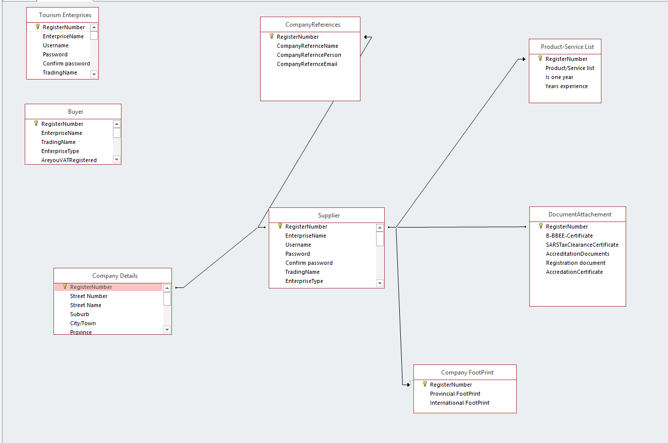
1:1
1:m
1:1
1:m
1:m
Figure 2 Database Relationship
- SCREEN DESIGN OF PLANNING

N.B This should not define how the screen actually will look but just show what should be included on the System. This document should allow the developers to think of new parameters that would make "the features" even more powerful and to create an environment which nurtures dynamics and creativity built upon the foundations. The Developers should explore many different approaches to solve specific user problem and to ensure that the product logically flows from one step to the next.

Field caption might be different from the particular field name, the field name must be descriptive/ explanatory of what is required from the user

User should be able to save unfinished form and be able to return and complete it.

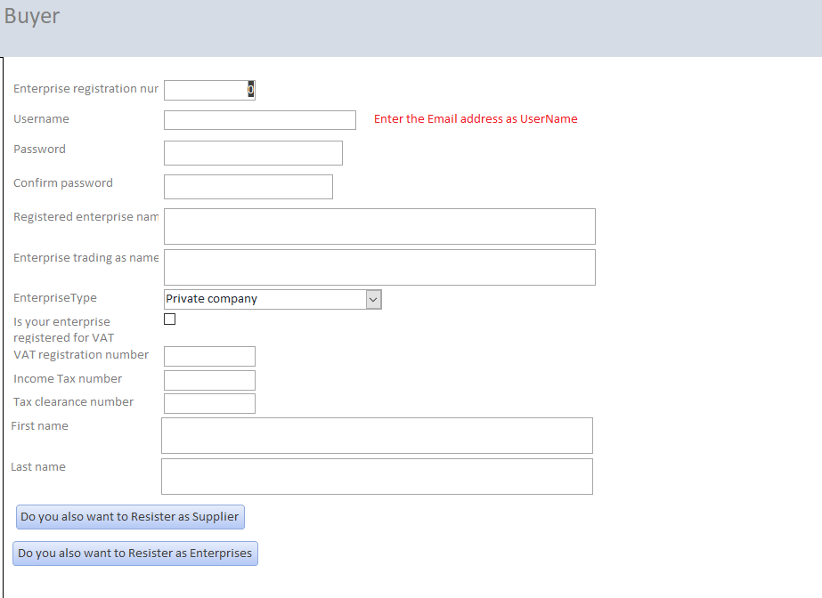

Figure 3 Buyer Form
If you want to register as Supplier or/and Tourism Enterprises you will not have to fill the fields that are similar on the Buyer form

Figure 5 will appear when “Do you want to Register as Supplier” Button is clicked, from the Buyer form.

The field Tourism Sector can have more than one options.

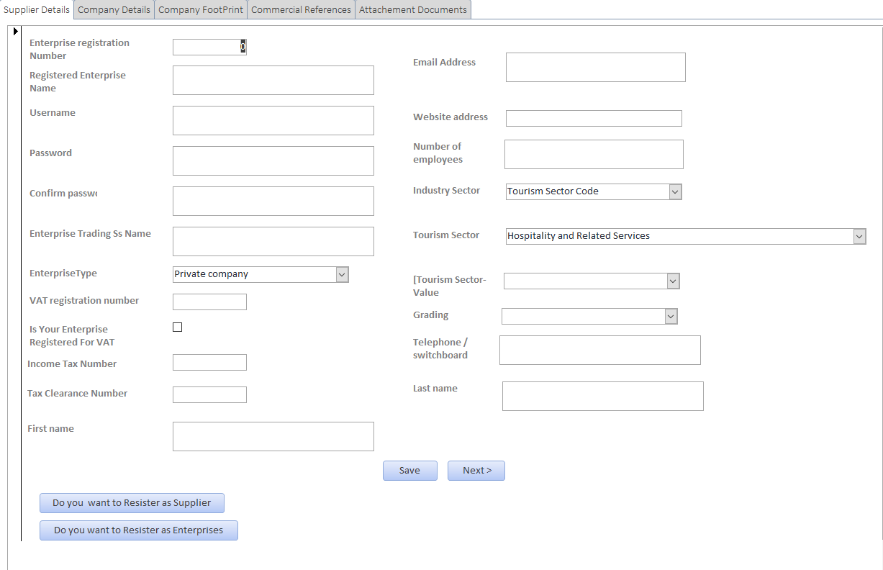

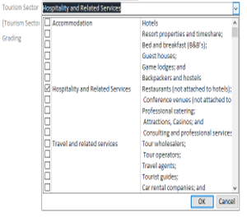

Figure 5 will appear when this button is clicked

Figure 11 will appear when this button is clicked

Figure 4 Supplier Form

Item list of Tourism
Sector dropdown component

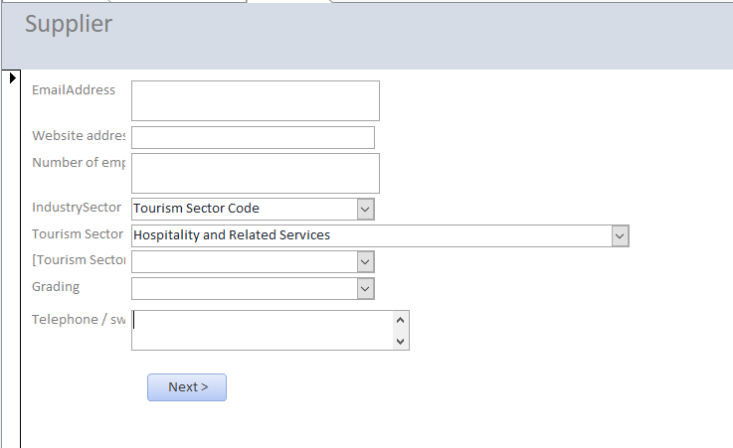

Figure 5 Supplier Form Continuation from Buyer Form
When next is clicked on the figure 5 the form on figure 6 will appear

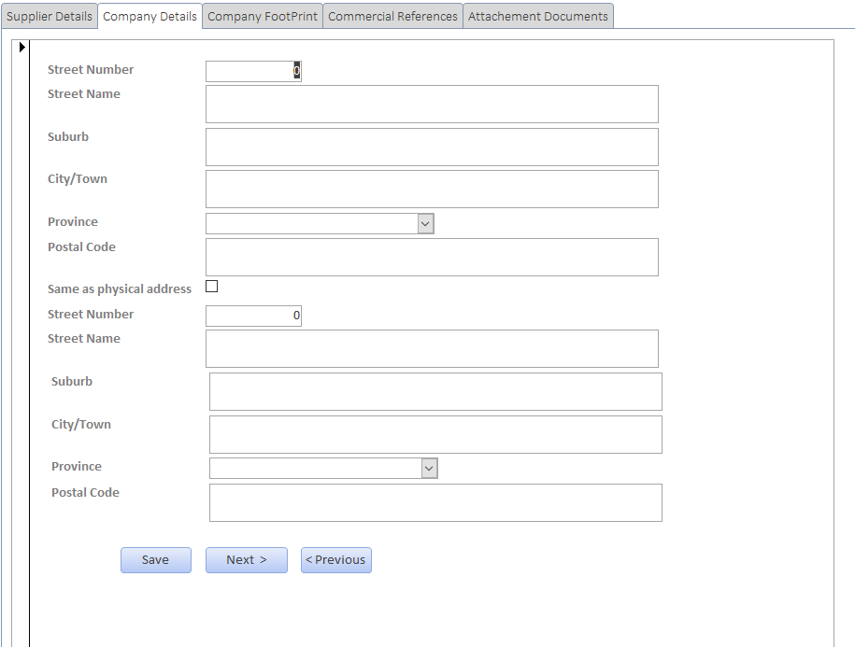

Figure 6 Company Details Form
The information on this form has one to one relationship with the supplier database, meaning one Company Registration will have one company details.

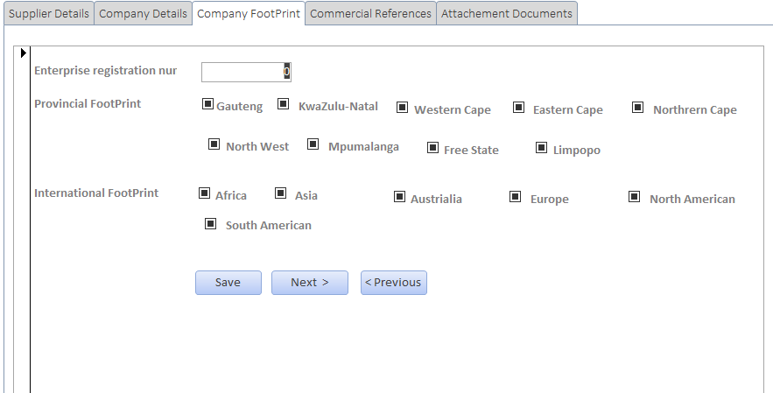

Figure 7 Company Footprint Form
The information on this form has one to many relationship with the supplier list/table, meaning one company registration can have multiple footprint

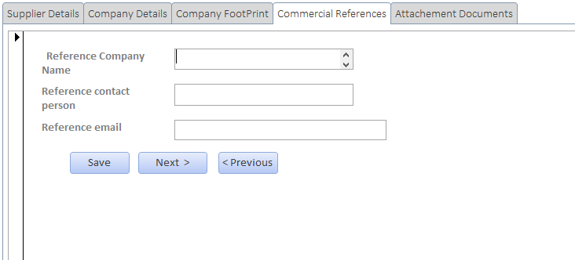

Figure 8 Commercial References Form

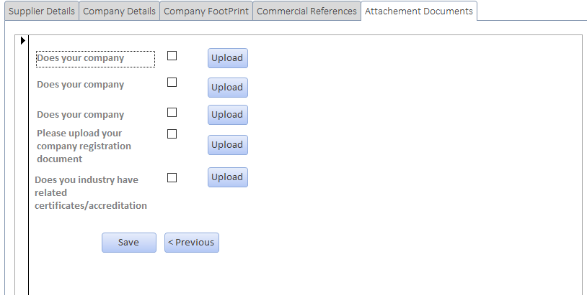

Figure 9 Attachment Documents Form
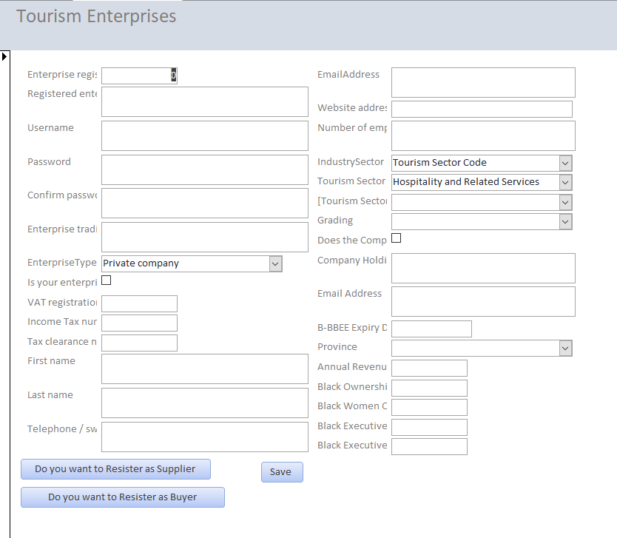

Figure 10 Tourism Enterprises Form
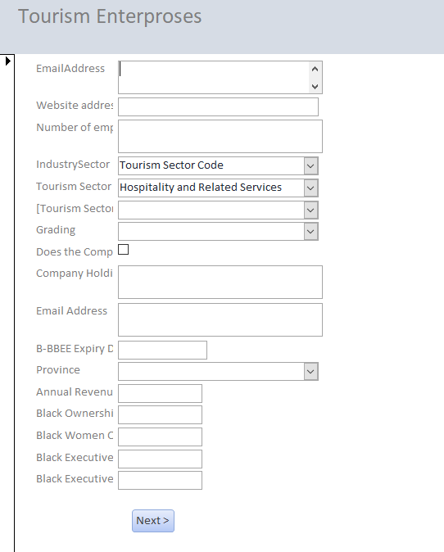

Figure 11 Continuation of Tourism Enterprises
The form on Figure 11 will appear when “Do you want to Resister as Enterprises” Button is clicked, from the Buyer form on Figure 4 .

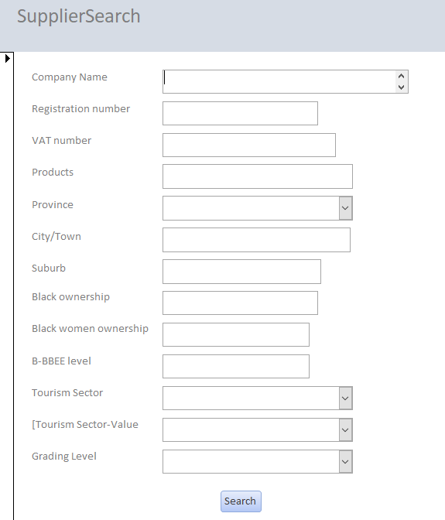

Figure 12 Search for Suppliers Form

Any field/s can be used to search, the system will not force to fill all the fields
- REPORTS
Reports design will be developed on the later stage of the development process.

